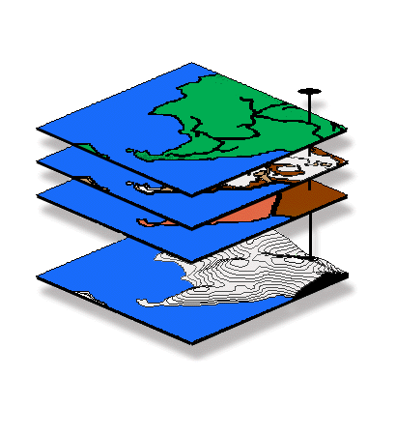

GIS "Tool-Time" Brown-Bag Session, DU Geography

Analyzing Spatial Data:

Spatial Interpolation and Statistics

Presentation by Joseph K. Berry, Keck Visiting Scholar

…a two-hour session with “hands-on” exercises in spatial interpolation of point sampled data and interpretation of the resulting map surfaces.

Thursday, April 26th
10am-12noon and 2-4pm (repeated sessions)
Room 125, Boettcher Center West

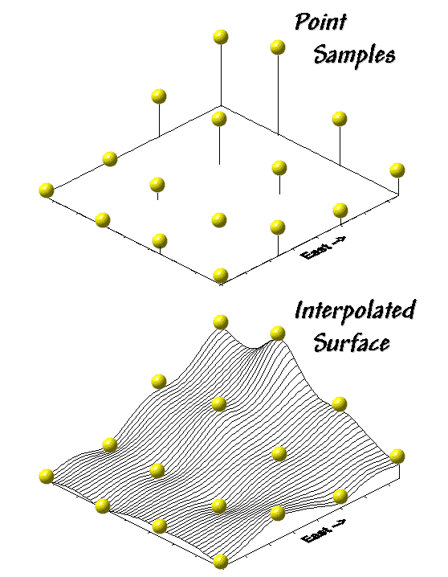
The ability to generate maps from a set of field samples is a rapidly developing segment of geographic information systems (GIS) technology. Traditionally, these techniques have been used to characterize familiar physical phenomena, such as elevation and temperature. More recently, map variables are being treated “map-ematically” as surfaces, such as population density, sales activity and soil nutrient levels, in exciting new applications that extend traditional non-spatial data analysis.

_____________________________________________________________________________________________

The Geography Department is sponsoring a series of “hands-on” workshops for faculty
and students interested in spatial techniques and procedures. Topics include…

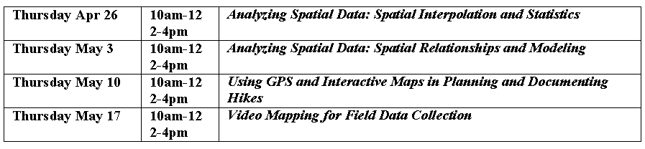
Please direct questions to Joe Berry at DU Extension 7531, email jkberry@du.edu

